Detoxification, Induced Self Tissue Repair and Restorative Medicine

DR. MED. JOSEF KEES, M. D.

Private Clinic for Restorative Medicine and Cellular Medicine
Bad Homburg v.d.H., Germany

Introduction

The human body in our industrial society becomes more and more somehow sealed against regeneration and rejuvenation and curing through normal standard therapy, nutritional therapy and supplementation by several factors.

Curing or improvement of health condition is based on the proper knowledge and understanding of

  - anatomical structures and functions of body parts and organ systems

  - histological structures and functions of tissues

  - biochemical processes and interactions in the different tissues

  - biophysical structures and energetic processes

  - mental and spiritual influences
The health of the human body has been and is more and more damaged by environmental pollutants, toxins, radiation and electromagnetic smog.

Increasing ecological damages, synthetic and artificial foodstuff, lack of physical exercise, proper breathing, shortage of sufficient supply with good water, pathogens like mutated virus, bacteria and funguses cause unnoticed cell damages with reduced cell function up to cellular malfunction, reduced immune defence, chronic diseases and finally can cause cancer.

This interrelation is based on a molecular biological interaction between the toxins, radiation effects and the intact and healthy biochemical and physiological natural properties of the human body and its different cells.

The environmental pollutants together with the shortage of vital substances and malnutrition only to a small part are damaging to health by acute effects, but much more important and much more obscure are the long-term effects to health.

The importance of environmental pollution to coming into being of chronic disease and the incidence of allergic, carcinogenic, mutagenic and teratogenic effects are only partly understood and even today are often denied.

Particularly difficult to overlook is the combined effect of the different pollutants.

The acute poisoning is better understood; it requires a specific therapy and a special antidote.

On the other hand, the chronic poisoning by pollutants and the effects of it are difficult to recognise and to deal with in medical practise.

Diagnostics

By exactly diagnosing the specific substances and quantities of pollutants in the body and in the body tissue and than designing a specific therapy schedule, the pollutants can be detoxified, led out and the tissue damages can be repaired by induced self tissue repair by application of specific remedies and therapies.

The exact causative diagnostical assessment is based on the following methodologies:

- biographical and medical case-history

- thorough physical examination

- Segmental Electrography (SEG)

- standard chemical laboratory testing

- special toxicological laboratory testing and monitoring

- HLB-Bradford blood testing

- X-ray, if needed

- CT = computer tomography or MRT, if needed

- kinesiology, iris diagnostics, reflex zone analysis

- theromography

- microscopy, dark field microscopy

The determining of the intensity of the therapy, the duration, the course of treatment and the success is assessed by the diagnostical parameters obtained in the beginning of the treatment and their control during the course.

The therapy

The pollutants and their toxic effects have disturbed the steady state balance in the body, in the body tissue and in the specific body cells according to their biochemical tissue affinity, chemical affinity and effects to biological molecules and according to their area of deposits.

These steady state imbalances as a cellular and tissue defect must be treated by specific means to address and adjust biochemical as well as biophysical fields of disturbances at the cell membrane to move the imbalance back to the natural and healthy steady state condition as well as to induce the metabolic effect to repair and undo the toxic and deficient effects of the pollutants and the malnutrition to the various bio-molecules.

The major therapeutic means for curing are the following

- oxygenation (CO elimination)

- alighting to water with sufficient quantity and quality (GIE levitated water)

- proper nutrition consisting of the right quality and suitable percentage share of
  - proteins and essential amino acids (MAP = master amino acid pattern)
  - carbohydrates (barley)
  - fat and essential fatty acids
(omega-3 fatty acid, linen oil)
- supplementation in the right the right quality and suitable percentage share of
  - vitamins (super antioxydants, Micrihydrin, EMX)
  - electrolyte
  - trace elements (unprocessed, natural salts)
  - enzymes
  - vegetable hormones (DHEA)
  - effective healthy microorganismen (EM)

- motion, physical activity, circulation

- mental and social wellness

- special remedies depending on
  - the kind or mixture of toxins electrolyte
  - the quantity of toxins acquired and deposited
  - the body condition, constitution
  - vegetable hormones
  - the fitness of the patient

This therapy has to be tailor-made and than supported and accompanied by specific and thoroughly tuned orth-molecular supplementation pattern of essential biochemical substances for detoxification and cell renewal, like vitamins (mega doses of vitamin C for example), essential amino acids pattern, trace elements, electrolyte, essential fatty acids, specific carbohydrates, and other biological remedies like extracts, vaccines and homeopathic remedies.

This must be also accompanied by cleansing of liver, bile system, intestines, kidneys and the mesenchyme, denture sanitation and as well as the specific cleansing and regeneration of the organ or organ systems which is most affected in the body of the patient.

This therapeutic scheme is put together in a certain and specific way and ends in a specific tailor-made causative treatment of the patient.

By monitoring and controlling the previously extracted biochemical and physical and physiological parameters the detoxifying and restorative process in the body can be monitored, controlled and steered.

Thus a causative, curative and restorative therapy and curing can occur.

Some results

This results obtainable can vary, depending on the kind of pollutant, the severity of exposure, contamination and ingestion and absorption, time of exposure, physical condition and nutritionary habits of the patient and, last but not least, the cooperation and participation of the patient.

The following cases are taken at random out of my clientele.

At the beginning of the therapy 4 weeks after treatment

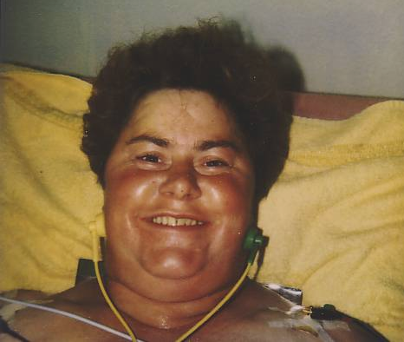

I. Z., 43 years, rheumatism since 12 years, chemist for 15 years in a big chemistry combine, had experimented with mercury and other toxic substances, under medical therapy with cortisone and pain killers for 8 years, constant deterioration und this medication, couldn’t hardly walk and was afraid to get confined to a wheelchair

At the beginning of the therapy 8 weeks after treatment

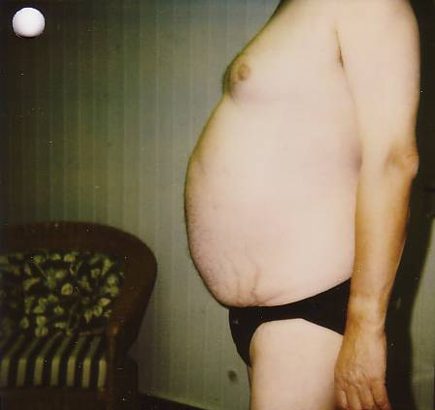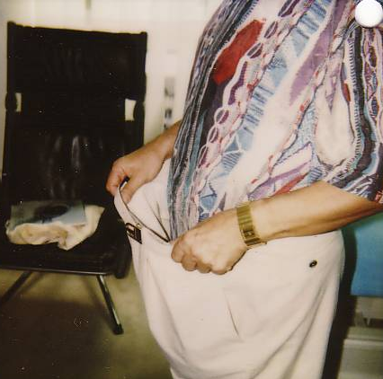

D. O., 57 years, diabetes since 25 years, severe polyoneuropaty, obesity, toxic poisoning of the liver, contaminated with nickel, mercury and other toxic substances, under medical therapy with tablets and pain killers for many years, no improvement under this medication and further deterioration, couldn’t hardly walk because of the sever neuropathical pain at the soles of his feet, he was afraid to die when he retired, because some of his friends did, had severest pain when showering and at his bald head when the wind blew over it.

At the beginning of the therapy 3 days after treatment

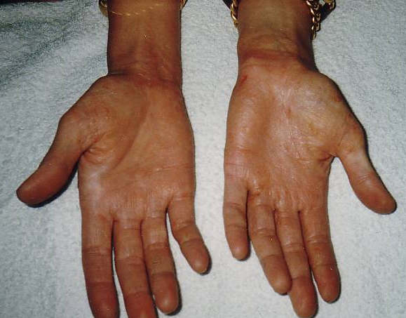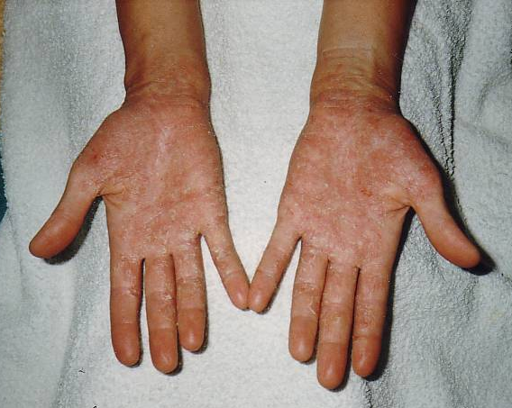

B. A., 36 years, before never diagnosed toxoplasmosis, candidosis, poisoning with Lindane, passionate golfer, since the early childhood bleeding, painful and gashed and scaly hands, nothing helped at all, constant deterioration, severe allergic reactions at the slightest contact with chemicals, under medical therapy with cortisone and pain killers, after two treatment sessions only the skin was repelled and renewed, for the first time perspiration at her hands again since years and no grains

23 days after treatment

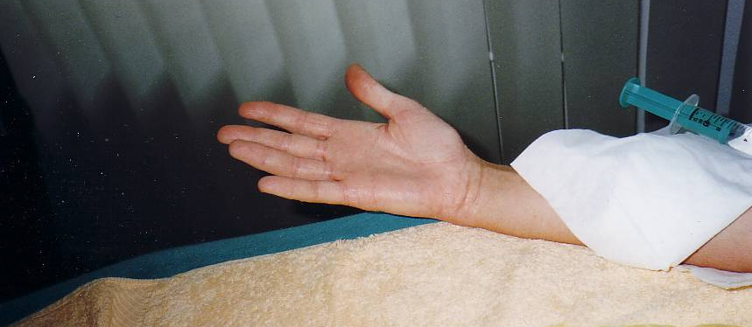

Conclusions

The specific diagnostic and medical methodology is complex and the application of such depends very much on the experience and subject and expert knowledge of the physician and cannot be the subject of this introduction into restorative medicine.

